

Sri Lanka Institute of Information Technology

**Hotel Management System**

Project Proposal

Information Technology Project 2014

Project ID: **ITP-14-MTR-03**

Submitted by:

1. IT13117474– Prasad Lakmal D.H.
2. IT13128050– Madushanka A.S.S.
3. IT13118082– Charitha D.G.
4. IT13118150– Wijesinghe A.M.
5. IT13087234– Piumal Dinuka W.
6. IT13060954– Ranathunga B.S.
7. IT13110062– Shyamal W.A.I.

Submitted to:

…………………………..

Ms. K.B.A.B.Chathurika



Date of submission

# Abstract

This is the document of the Project proposal for developing a hotel management system for Gayana hotel. It consists of the current background of the hotel and problems having due to present system and how we are going to overcome those matters through our proposed system.

After gathering requirements we have found that Gayana hotel is using a manual file based system for their processes. They are keeping a huge amount of files to handle guest details, bills, inventory items...etc. Search for a record in the file system is really harsh. Although they are not well secured there is a probability of getting damaged due to a fire or a tsunami or any other kind of a disaster.

The project aimed to build a fully functional system in order to achieve the efficiency in the hotel management. The overall mission of system development is to make the hotel staff can quickly and easily complete the hotel management task.

.

# Table of Contents

**Abstract** I

**Table of Contents** II

**1.** **Introduction** 1

**1.1** **Problem Specification** 2

**1.2** **Solution Outline** 4

**1.3** **Key Benefits** 6

**2.** **Objectives** 7

**3.** **Procedure** 10

**3.2** **Project Plan** 13

**4.** **Personnel and Facilities** 18

**5.** **Software and Hardware Requirements** 19

**6.** **Budget** 20

**7.** **References** 21

**Table of Figures**

**Figure 1.2.1 High Level Architecture……………………………………….……………………...5**

**Figure 3.1.1 Prototype Model…………………………………………………………………..….10**

**Figure 3.1.2 General Working of the system…………………………………………………...…12**

**Figure 3.2.1 Project plan cycle……………………………………………………………………..13**

**Figure 3.2.1 Gantt chart…………………………………………………………………………....17**

**Tables of Tables**

**Table 3.2** Project Development Phases 13

**Table 4.1** Roles and Responsibilities 18

**Table 6.1** Budget 20

**Table 6.2 Software and Hardware Cost....................................................................................…...20**

# Introduction

Gayana hotel is one of the famous tourist hotels located at tangalle coast line. Its history extends up to 60 years. Most of the tourist visit tangalle choose Gayana hotel due to several reasons such as the iconic location, panoramic view of the sea from hotel. At present about 50 employees are working attached to several departments of the hotel. Both local and foreign guests reserve rooms, conduct meetings, celebrate cocktail parties, weddings and many more other functions at hotel. Employee is the key role of the hotel. They have assign to keep room records, reservation details, clean rooms wedding halls; control the inventory of hotel and many more other responsibilities.

Currently Gayana hotel is using a manual system to handle hotel processes. When a guest make a reservation, all the reservation details (including guest details) are recorded in a file and those files are stored in a special cabinet. Calculations of bills and inventory items are done by manually too.

As the current system is a file based one, management of the hotel has to put much effort on securing those files. They can be easily get damaged by a fire, insects or even by a natural disaster like tsunami. Keeping files takes much time and wastes much precious man hours. Although we can’t trust the accuracy of calculations done by manually, it’s not a surprise of encountering problems. If we want to check for a previous room record or a reservation detail, management will be in a great problem. It’s a tough and time taking process to search for a record in a file.

The Hotel Management System we are going to implement will be covering all the basic processes done in the Hotel. It would handle Guest details, Reservation details, Inventory management details, Room service details, staff management details and room types.

All the above mentioned details and information are stored in the system database. It could save time when retrieving data from the database. Interfaces will be designed user friendly and the functions will be displayed in a simple manner.

The System we are going to develop will give remedies for the problems that are currently facing by our client. Shifting to our system can acquire advantages such as saving of time, man hours, and space wastage. This will increase the efficiency in hotel daily activities.

## Problem Specification

As we declare previously all the processes of Gayana hotel are handled by a manual method. Employees and the management of the hotel are responsible in handling the above processes. Especially management is responsible for adding new staff members, getting annual reports of the hotel and updating stocks.

All the information about reservation details, guest details, room services, room types, staff details, billing details, payment details are recorded in a file manually. They are stored in a special place which takes a huge space. Although they are arranged by the year, it’s difficult to find for a specific record within those files. Probability of getting damage of those files is high. When a guest makes a reservation, the receptionist has to keep reservation details in two separate places. It’s a time consuming thing. Even though the same guest visit hotel again and again, a new file is created for each time he visited. So the same guest details are copied to files recurrently. It causes for increasing of files and wastage of physical space. When a top level person of the management asks for a specific detail such as number of tourist visit their hotel last year, staff will be in a great problem. It may take hours to get through files and to gather the required detail. Guest will receive a bill including all his room charges and all other expenses at hotel when he or she checks out. This bill is calculated manually by collecting room type, food and beverages consume, number of days spent, room services. The person who makes the bill needs to refer to the cost chart and create the bill. This is time consuming and can’t assure the accuracy of the calculations.

If we summarize all the drawbacks of manual hotel management system we can mention as follows

• It is much time consuming.

• Often the data are lost and the employee or manager is not aware of this.

• Lots of Manual labor is required for manual record keeping.

• Data is not always reliable as it is hand written and some human errors might have occurred example wrong telephone number among other.

• Difficulty of searching and retrieving records.

• Slow process of reservation.

• Low in security.

• Files are prone to theft unauthorized modification due to low data security levels and standards.

• Retrieval of guest records is extremely difficult.

Above mentioned teasers caused for the decline of efficiency of the hotel and caused for many inconveniences in performing daily tasks at hotel.

The manual handling of hotel management system has always been a difficult task. Administering the smallest of the requirements of the guests to the basic needs the Hotel Management System have to put a lot of energy in controlling and executing the day-today work along with the miscellaneous items? However, the introduction of the hotel management software has diminished the possibilities of error and limitation of the staff to provide a specific service on any given time

## Solution Outline

Hotel Management System we are going to build will troubleshoot for all the problems previously mentioned in Problem Specification. The system will be implementing with more additional features that will support in achieving future goals of the hotels.

The system database will store all the details and information about reservations, guests, room services/types and staff details in a convenient manner. Database makes retrieval of data efficient and accurate. User of the system can easily search for a record by inserting any title. Reservations of the hotel can be done in a single click with no time. After checking availability for rooms, single or group reservation can be made after entering required details. Reports can be generated under several categories at any time whenever required. They will appear in a clear view with charts and graphs for easy comparisons. In the end of the month management can get a crystal clear view of the status of the hotel through those reports. By referring to those reports they can make future plans or take decisions that involve with the development of the hotel. When a guest checks out from the hotel he or she will get a printed version of the bill including all expenses. System has a function to automatically calculate the bill according to the predefined charges set to items, food and rooms. Higher level person of the hotel has the ability to change those unit prices after login to the system. Security is provided to our system by having a database backup, restore database and crash recovery system**.** User IDs and passwords are provided to prevent access of unauthorized people.

The system we are going to be built will upgrade the quality of the hotel and simplify the matters of the current manual system having.

Manager



View

Insert

Update

Delete

Add

Update

Delete

Add

Update

Reports

Department Details

Department Details

Department Details



Room/Staff/InventoryDetails

Room/Staff/InventoryDetails

Room/Staff/InventoryDetails



GuestDetails

GuestDetails

Delete

GuestDetails

Search

Rooms

Make

Reservations



Owner

Receptionist

Issue

Bill

**Figure 1.2.1 High Level Architecture**

## Key Benefits

The system we are going to build will provide solutions for the problems current manual system facing. Primary benefits that can be acquired by shifting to Hotel Management System are displays as follows.

**Generate Reports**: - System generates detailed reports that provide a clear picture of what’s going on with hotel property and help management to make the appropriate decisions and adjustments

**Time Savings**: - Hotel Management System will search and retrieve a required data in a flash. It saves the time that currently spending on refereeing to files and records.

**Security: -** System makes data and information secure by providing User IDs and passwords in order to prevent unauthorized access.

**Backup and restoring: -** Database backup makes helps to protect database data from theft, physical damage and computer viruses and malware and the records will be more secure than in file based system. Hotel Management can restore the system database if there is a need.

**User Friendly Dashboard: -** The Proposed System providesa user friendly background as well as user friendly functions. After login to the system user can get a quick view of all system bookings, events and room availability for the week ahead, Manage check-ins and room allocation at the touch of a button

**Email Reminder: -** For bookings, an e-mail reminder will be sent to guest.

1. **Objectives**

Our new Hotel management system is the ideal software solution for the hospitality industry that can be used at hotels, motels, inns, resorts, lodges, hostels, military guest houses, suits, apartments and bed & breakfast operations.

This product covers various aspects in hotel management and always performs user friendly. It helps to ease staff with facilities for reservation process. It saves the time which was wasting more and more in manual performance of hotel and that time can be used in effective way to enhance the revenue. The system can be divided into Departments according to their various functions.

**Inventory management Department**

Inventory management lets managers automate the process of tracking rooms, and food and beverage consumption in the hotel. Manually checking each and every inventory is wasting lot of time and a huge waste of effort. With the new system automation of the inventory management means lesser work and greater visibility into inventory stock.

There are numerous operations in inventory which happen simultaneously, these include sales through point of sale terminals, room service, purchase of food, beverages and other room related consumables and durables. Tracking all these activities can be difficult and if not tracked adequately can result in revenue leakage, wastage, and theft. Good system helps manager to predict demand and supply rate with great accuracy and reduce the chances of error. It also helps to predict expenditure and keep good control in profit. Using our system means achieving those benefits

* Update stock **-** System can update the current stock by adding new items. It’s simple and efficient rather than in manual system.
* Check Availability – When the manager wants to see the current inventory items he or she can get the help of this function. This function displays current status of the inventory. Referring to the outcome of the function, manager can easily decide what items they need to add to the inventory.

**Reservation department**

The Reservations Department is usually the first point of contact between guest and the Hotel. The Department is to accept and process all reservations and requests, control room and rate availability, operate and update the guest history and maximize room sales through effective use of rate controls, upselling and yield management.

• Availability status – check whether the requesting room/function is available or not.

• Room booking – Reserve a room by room type, rate, and to accommodate all the possible special requests of the guest.

• Function/Event booking – Reserve halls, party equipment for special events

• Arrival list – Retrieve the information of costumers and reservations according to requested date

• Booking confirmation letter – Make a confirmation Letter after completing the reservation

**Room management**

• Room status - The most important aspect of this monitoring process is discerning what guest rooms are available for sale and when. Room status categories/designations are grouped by the guest room’s state of occupancy and state of cleanliness.

State of occupancy

Vacant—the guest has checked out of the room

Ready—room is available for new guest

State of Cleanliness

Dirty—room has not been cleaned by housekeeping

Clean—room has been cleaned but not yet verified as clean

**Administration Department**

**•** Handle user accounts, user levels and their privileges – There are three levels of users in the system, which are, owner, manager and the receptionist. Adding, modifying and removing those users are done by here. Access to these features is available only for the owner.

• Take a backup of the system - On the security purposes each and every day, a backup of the database is taken from the system. It will be stored in another server according to the user’s requirement. User also will be given the ability of taking a backup of the system, in anytime when the user wants. Owner has the right to

**Guest Management**

* In the gust management we can handle the details of the guests visiting the hotel. When a new guest arrives we can add his or details to the database. Edit function is useful when a guest needs to edit his details, but editing of all the fields are not allowed in our system. Once a guest checks out he will receive a printed version of the finalized bill calculated by our system.

**Staff Department**

* Hotel staff can be managed by the manager as well as owner of the hotel. Manager has the privilege to edit staff member details. Owner is responsible for add or delete a staff member from the system.

# Procedure

## Flow of the Project

The designing and implementation of Hotel Management System for Gayana hotel begin with the gathering of requirements and examine the background of the hotel. Although the current system is a manual and file based one, we realize that the system we are going to build must give the solutions for wastage of time and space which affects the efficiency of the daily activities performed at the hotel. We have decided to use prototyping model to develop Hotel Management System. Therefore the system is developed in increments so that it can readily be modified in response to end-user and customer feedback. A prototype is built with basic and critical attributes. The designers build the database, user interfaces and developers build working functions. After the user evaluates the prototype he or she suggests improvements. This loop continues until the user is satisfied. As the primary step we have to gather requirements.

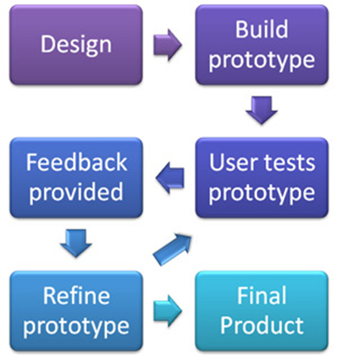

**3.1.1 Prototype Model**

After a simple meeting with the hotel management, we were able to gain more details and processes that need to be considering in building the system. Requirement gathering process was done by using some techniques such as interviewing and observations. Interviewing with the manager, workers and the head of the hotel face to face is beneficial to the system and clear out many differences regarding requirements about the system. We found the all requirements that have to be computerize such as billing details, guest details, room details and hotel staff details. By refereeing to files and records that have been keeping by the hotel, we got a clear idea about the required fields. The requirements gathering we have done helped us in identifying the entities, attributes and the relationships of the scenario of the hotel and the information we gathered helped us to decide the data that we should handle in the system database. The functions of the system that is going to be designed has to be met with the customer requirements and the outcomes of the functions should have to be addressed the problems that we have encountered during the requirement gathering phase. The customer requirements identified during the requirements and analysis activity are organized into a SRS document. The important components of this document are functional requirements and non-functional requirements, and the goals of implementation.

We break down the system into several departments such as inventory, administration, guest, room, reservation, billing, room services etc. in order to make the functionality of the proposed system simplify. Then we analyze each department and submit them to different group members. Interfaces are design in a user friendly manner, according to the requirements.

After the requirements gathering we identified the needs of the hotel. According to the gathered data we draw the E-ER diagram which is the key to the database of the system. All the entities, attributes and relationships of the scenario are drawn by us and later we completed it with cardinality ratios and participating constraints. Mapping of the E-ER is the next step, after finishing it normalization step will be proceed and produce the database tables with no redundancy and inconsistency.

Completion of database and interfaces will guide to coding part of the project. The purpose of the coding unit of the project is to translate the software design into source code. Each component of the design is implemented as a programmed module. We will use C# language as a programming language to build the system. The platform these codes will be run is .NET frameworks. The software Microsoft Visual Studio will be used to implement the codes here. Microsoft SQL Server Management Express will be used to create the database. During the coding part we will use field validators in order to prevent the insertion of inconsistent data into the system database. User-friendly error messages will be displayed in such case.

Testing is the next important phase of project. Before the system testing we have to conduct the unit testing. During this phase, each module is unit tested to determine the correct working of all the individual modules. It involves testing each module in isolation as this is the most efficient way to debug the errors identified at this stage.

Afterwards integration of different modules is undertaken once they have been coded and unit tested. During the integration and system testing phase, the modules are integrated in a planned manner. The system testing will be performed by us and later it will be tested by hotel staff members. Finally the acceptance testing will be performed by the manager himself after the product delivery to determine whether to accept or reject the product. In any case where the system is not meeting up with the requirements of the client, functions will be redesigned and built according to the satisfaction of the management of the Hotel.

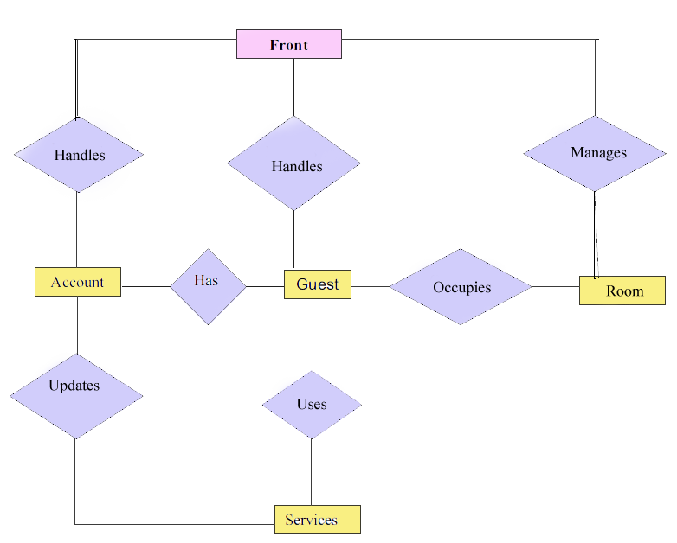

**3.1.2 General Working of the system**

## Project Plan

Project planning is a discipline for stating how to complete a project within a certain timeframe, usually with defined stages, and with designated resources.

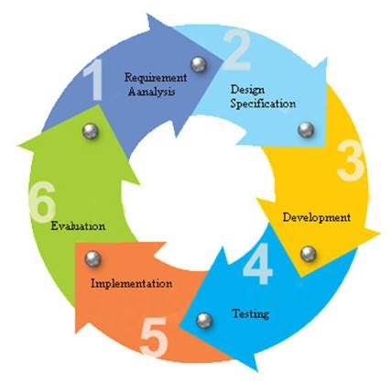

**Figure 3.2.1 Project plan cycle**

**Table 3.2** Project Development Phases

|  |  |  |  |
| --- | --- | --- | --- |
| **Phase** | **Primary Objective** | **Time Period** | **Duration Estimation** |
| Feasibility Study | At the first glance it seems little bit unrealistic to create a system for Gayana Hotel.it was a challenge to determine whether the solution we are going to come up with will be financially worthwhile and technically feasible. But by identifying specific departments that require better solutions, it had been decided that, an information system to the business, can be implemented and it will increase the quality and the performance of the system than the current one. | 6/23/14 to 6/26/14 | 3 days |
| Requirement Analysis and Specification | In this phase it encompasses those tasks that go in to determining the needs or conditions that should be included in the system that is going to be implemented. The members of the group is required to conduct meetings and negotiations daily in this period of the phase to gather the information, requirements and to have a clear idea about the system that is in progress.  Then the analysis of the requirements that has been gathered should be done in a specialized manner.  After the gathering and the analysis of the requirements the team should perform the requirement specification. | 6/26/14 to 7/11/14 | 15 days |
| Software Design | This is the transitional phase of the project. Here the design moves from schematic phase to contract document phase. In this phase the crew should prepare drawings and other presentation documents, crystallize the design concept and describe it in terms of architectural, electrical, mechanical and structural system. | 7/14/14 to 8/1/14 | 15 days |
| Development and  Integration | In this phase the designed functions in above phases will be implemented as codes using the language C# in this project.  Here the connection of the Crystal reports should also have to be considered when the functions are implemented. | 8/3/14 to 8/28/14 | 20 days |
| Testing | The Test Phase focuses on a technical investigation in which the results describe the quality of the system. Testing cannot confirm a system functions properly under all conditions but can establish that it fails under specific conditions. Those possible conditions and the bugs of the system will be identified in this phase of Testing.  The project crew will work here to test several kinds of testing. Such as,   * Unit testing * Integration testing * Regression testing * System Testing | 8/29/14 to 9/29/14 | 30 days |
| Deployment  (Installation) | This is the phase that the crew handover the system in to the hands of the client to its environment that the system will be prevailed long term. | 9/30/14 to 10/1/14 | 2 days |
| Maintenance | Maintenance part is the phase that requires the most effort within the entire life cycle of the project.  The modification of a software product after delivery to correct faults, to improve performance or other attributes, or to adapt the product to a modified environment." Software maintenance is the concluding part of the software development process.  Here if the client wants any modification of the functions of the system or to add new features to the system, the project team should be ready to render the service to the client. | 10/1/14 to 2/3/15 | 90 days |

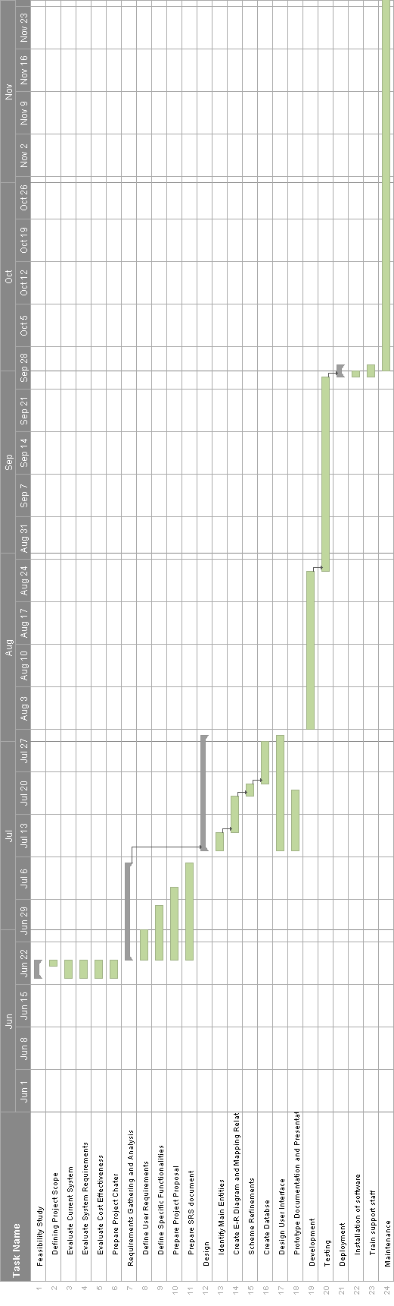

**Figure 3.2.1 Gantt chart**

# Personnel and Facilities

|  |  |
| --- | --- |
| **Role** | **Responsibility** |
| System Analyst | * Facilitate requirements gathering. * Documenting of project requirements. |
| Designers | * Analyze Software requirement specification. * Convert the requirements into a programmer understandable manner. |
| Developers | * Code the solution using C#.Net language |
| DB Administrators | * Create database following the standard steps of relational database designing * Do modifications and maintain the database according to the requirements of the other developers |
| Testing people | * Assuring stated business goals and objectives are satisfied |

**Table 4.1** Roles and Responsibilities

# All members will be performing any of the above mentioned roles

**Members**

* + IT13117474 - Prasad Lakmal D. H.
  + IT13128050 - Madushanka A. S. S.
  + IT13118082 - Charitha D. G.
  + IT13118150 - Wijesinghe A. M.
  + IT13087234 - Piyumal Dinuka W.
  + IT13060954 - Ranathunga B. S.
  + IT13110062 - Shyamal W. A. I.

# Software and Hardware Requirements

# Hotel Management System consists of 3 main user levels. They are Receptionist, Manager and Owner. Each user levels have privilege access according to their priority to different user interfaces.

# Program installation needs about 200MB of disk space. The database and the management software will require nearly 10GB of hard disk space on the server.

**Hardware Requirements**

1. **Operating System** Supports all known operating systems, such as Windows, Linux
2. **Computer** 512MB+ RAM, monitor with minimum resolution of 1024x768, keyboard, and mouse
3. **Hard Drive** should be in NTFS file-system formatted with minimum 10 GB of free space
4. **A Laser printer** will need to be used to print these reports and notes

**Software Requirements**

1. Software is designed to run on any platform above Microsoft Windows 7 (32bit).
2. Microsoft .NET Frameworks 4.0 or above.
3. Microsoft SQL Server Management Studio Express 2008.
4. Crystal reports runtime library.

# Budget

**Table 6.1** Budget

|  |  |  |  |  |  |  |  |  |  |
| --- | --- | --- | --- | --- | --- | --- | --- | --- | --- |
|  | |  | | --- | | **Person name** | | |  | | --- | | **Number of man hours** | |  | | |  | | --- | | **Rate for one man per hour (Rs)** | | |  | | --- | | **Cost** | |
| 1. | Prasad Lakmal D.H. | 200 | 100 | 20,000 |
| 2. | Madushanka A.S.S. | 200 | 100 | 20,000 |
| 3. | Charitha D.G. | 200 | 100 | 20,000 |
| 4. | Wijesinghe A.M. | 200 | 100 | 20,000 |
| 5. | Piumal Dinuka W. | 200 | 100 | 20,000 |
| 6. | Ranathunga B.S. | 200 | 100 | 20,000 |
| 7. | Shyamal W.A.I. | 200 | 100 | 20,000 |
|  | **TOTAL** | 1400 | **_** | **140,000** |

**Table 6.2** Software and Hardware Cost

|  |  |
| --- | --- |
| **Resource** | **Cost** |
| Microsoft Visual Studio 2010 | Rs. 15,000 |
| SQL Server Management Express 2008 | Rs35,000 |
| Microsoft Office 2013 | Rs 65,000 |
| Three Desktop Computers | Rs 120,000 |

**Total Cost for Project (LKR) = 140,000 + 115,000 + 120,000**

**= 375,000**

# References

# Books:

# [1]Ian Sommerville, *Software engineering*, 9th edition, Pearson education, 2011.

# [2]Rajib Mall, *Fundamentals of Software Engineering*, 2nd edition, PHI Learning Pvt. Ltd, 2004.

# [3]Ragu Ramakrishnan, Johnes Gehrke, *Database Management Systems,* 3rd edition, McGraw-Hill

# Education, 2003.

# [4]Gerald W. Latin, *Modern hotel management*, W.H.Freeman, 2011.

# World Wide Web:

# [5]”Hotel Management Case Study”, March.6, 2010. [Online].Available:

<http://www.scribd.com/doc/27927992/Hotel-Management-Case-Study>, [Accessed: June.28, 2014]

[6]”High-Level-Software Features”, [Online].Available:

<http://www.high-level-software.com/features/>, [Accessed: June.25, 2014]

[7]Fernandez & Yuan, X,(1999). *An analysis Pattern for Reservation and Use of Reusable Entities*. PloP 1999 conference, Retrieved from <http://hillside.net/plop/plop99/proceedings/Fernandez2/reservanalysisPattern3.PDf>

[8]Lauesen, S, (2003), *Task Descriptions as Functional Requirements*, IEEE Computer Society, Retrieved from <http://www.itu.dk/~slauesen/Papers/IEEEtasks.pdf>

[9]Louw,D,(2006, may 10).*Description with UML for a Hotel Reservation System*. Retrieved from

<http://www.liacs.nl/assets/Bachelorscripties/2006-08JanneLouw.pdf>

# 